EMPLOYEE EXPENSE TRACKING SYSTEM

USER MANUAL

TWIN-CIRCA MARKETING

ESPOSADO VILLAGE, CANNERY SITE

POLOMOLOK, SOUTH COTABATO 9504

**USER MANUAL VERSION: 1.0**

**MARCH 2021**

Table of Contents

Introduction 1

General Information 1

System Overview 1

Common Features 1

System Requirements 2

Hardware Requirements 2

Software Requirements 2

Getting Started 3

Starting the Web Application 3

Navigating the Web Application 3

Application Bar 3

Page Content 3

Navigation Drawer 4

Footer 5

Working with Data Tables 6

Filtering Data Table 6

Sorting Data Table 6

Refreshing Data Table 7

Showing Additional Row Data 7

Selecting Rows 7

Perform Actions on Rows 8

Pagination 8

Filtering Records 9

Search Bar 9

Date Range Picker 9

Status Filter 10

Access, Authentication, and Authorization 13

Signing in to the Application 13

Exit the Application 13

Application Modules 14

Dashboard 14

Expense Summary 15

Expense Reports Summary 15

Expense by Category 15

Expense by Date 16

Filtering Records 16

Profile 17

Updating Information 17

Change Password 17

Expense 19

Creating New Expense 19

Editing Expense 21

Expense Status 22

Viewing Expense 22

Cancelling Expenses 23

Restoring Expenses 23

Expense Report 25

Creating New Expense Report 25

Editing Expense Report 27

Viewing Expense Report 27

Expense Reports Status 28

Submitting Expense Reports 28

Printing and Exporting Expense Reports 29

Cancelling Expense Reports 29

Duplicating Expense Reports 30

Payment 31

Viewing Payment Record 31

Payment Record Status 32

Confirming Payment Records 32

Notifications 34

Viewing Notifications 34

Changing Notification Status 35

Appendices 37

Figures 37

Troubleshooting 39

Software Troubleshooting 39

Common Response Errors 39

# Introduction

## General Information

This user manual has been created to outline the setup and system functionalities. This includes the system requirements, proper setup and configuration, tutorials for application modules, and other system considerations and specifications. This document also provides an overview of the system to depict different aspects of the system and functions as a reference for system users.

## System Overview

The Employee Expense Tracking System is a web-based application that manages travel-related expenses of employees. It allows users to record, submit, track, process, and reimburse employee expenses. The system used to improve and streamline current process, data management and increase response time.

## Common Features

*Record Keeping*

The application is used in storing data to keep accurate records. Usual data that comprise overall transaction include employee information, vendors, expenses, and payment records.

*Status Monitoring*

The application is used for monitoring status of records mainly on expense reports submission and approval to avoid delays on employee reimbursement.

*Reporting*

The Employee Expense Tracking System provides an accurate data visualization for reporting and analysis. The system can generate summary of expense reports as well as overall expenses of the company.

## System Requirements

The minimum requirements for running the application required to operate the Employee Expense Tracking System are listed below:

### Hardware Requirements

* 1 x LCD/LED Monitor
* 1 x Computer Mouse
* 1 x Keyboard
* 1 x System Unit
  + 1 x VGA port
  + 2 x USB port
  + 1 x Ethernet port
  + RAM: 1 GB (32-bit) or 2 GB (64-bit systems); Recommended 4 GB or above
  + CPU: 1 GHz or higher
  + Hard disk space: 16 GB (32-bit) or 20 GB (64-bit systems); Recommended 64 GB or above
* 1 x Inkjet Printer (300*300 DPI)
* Ethernet connection (LAN) or a wireless adapter (Wi-Fi)

### Software Requirements

* Operating System (Recommended: Latest version)

Supported operating systems include:

* + Microsoft Windows 7 / 8 / 10
  + MAC OS X 10.4 or later
  + Linux v.20 or later
* Web Browser (Recommended: Latest version)

Supported web browsers include:

* + Google Chrome v.58 +
  + Mozilla Firefox v.54 +
  + Microsoft Edge v.14 +
  + Safari v.10 +

# Getting Started

## Starting the Web Application

To access the application, open a web browser in your computer and then type in the link *http://192.168.1.99:82/* in the browser’s address bar. In the application, the login page will be loaded first, enter the username and password and click the Login button. The username and password are verified and cached on the Web application server for the remainder of the session. After a successful login, you will be redirected to the dashboard of the application.

## Navigating the Web Application

### Application Bar

The application bar is the primary source of site navigation found on topmost section of every page. This consists of a navigation drawer menu, the home menu (labeled as the application’s name), notifications menu, and logout menu.



Figure 1 Application Bar

### Page Content

The page content refers to all the information contained in a website. Page content can be displayed as text, links, images, audio, animation or videos among other things.

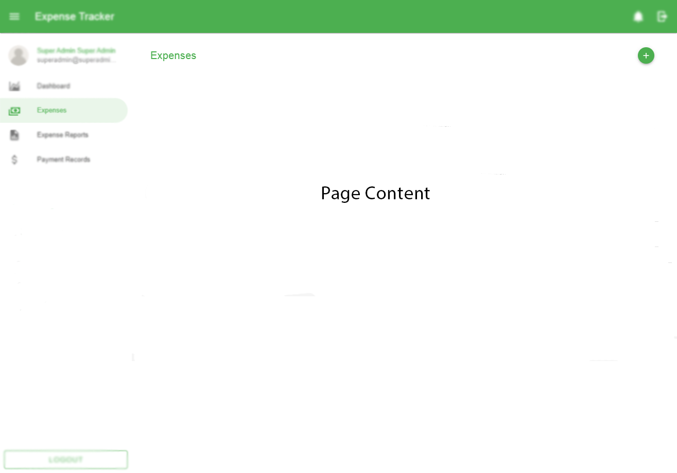

Figure 2 Page Content

Common Page Content menus:

* + Page Title – This is used to specify the content of the webpage. Located at the top-left or top-right corner of the page.
  + Action Buttons – This is used to perform specific actions such as links which redirect the user to other pages.
  + Back button – This is a backward pointing arrow that returns the user to a previously shown window or web page.

### Navigation Drawer

The navigation drawer is what the users will utilize to navigate through the application. This is primarily used to house links to the pages and found on the leftmost section of the application.

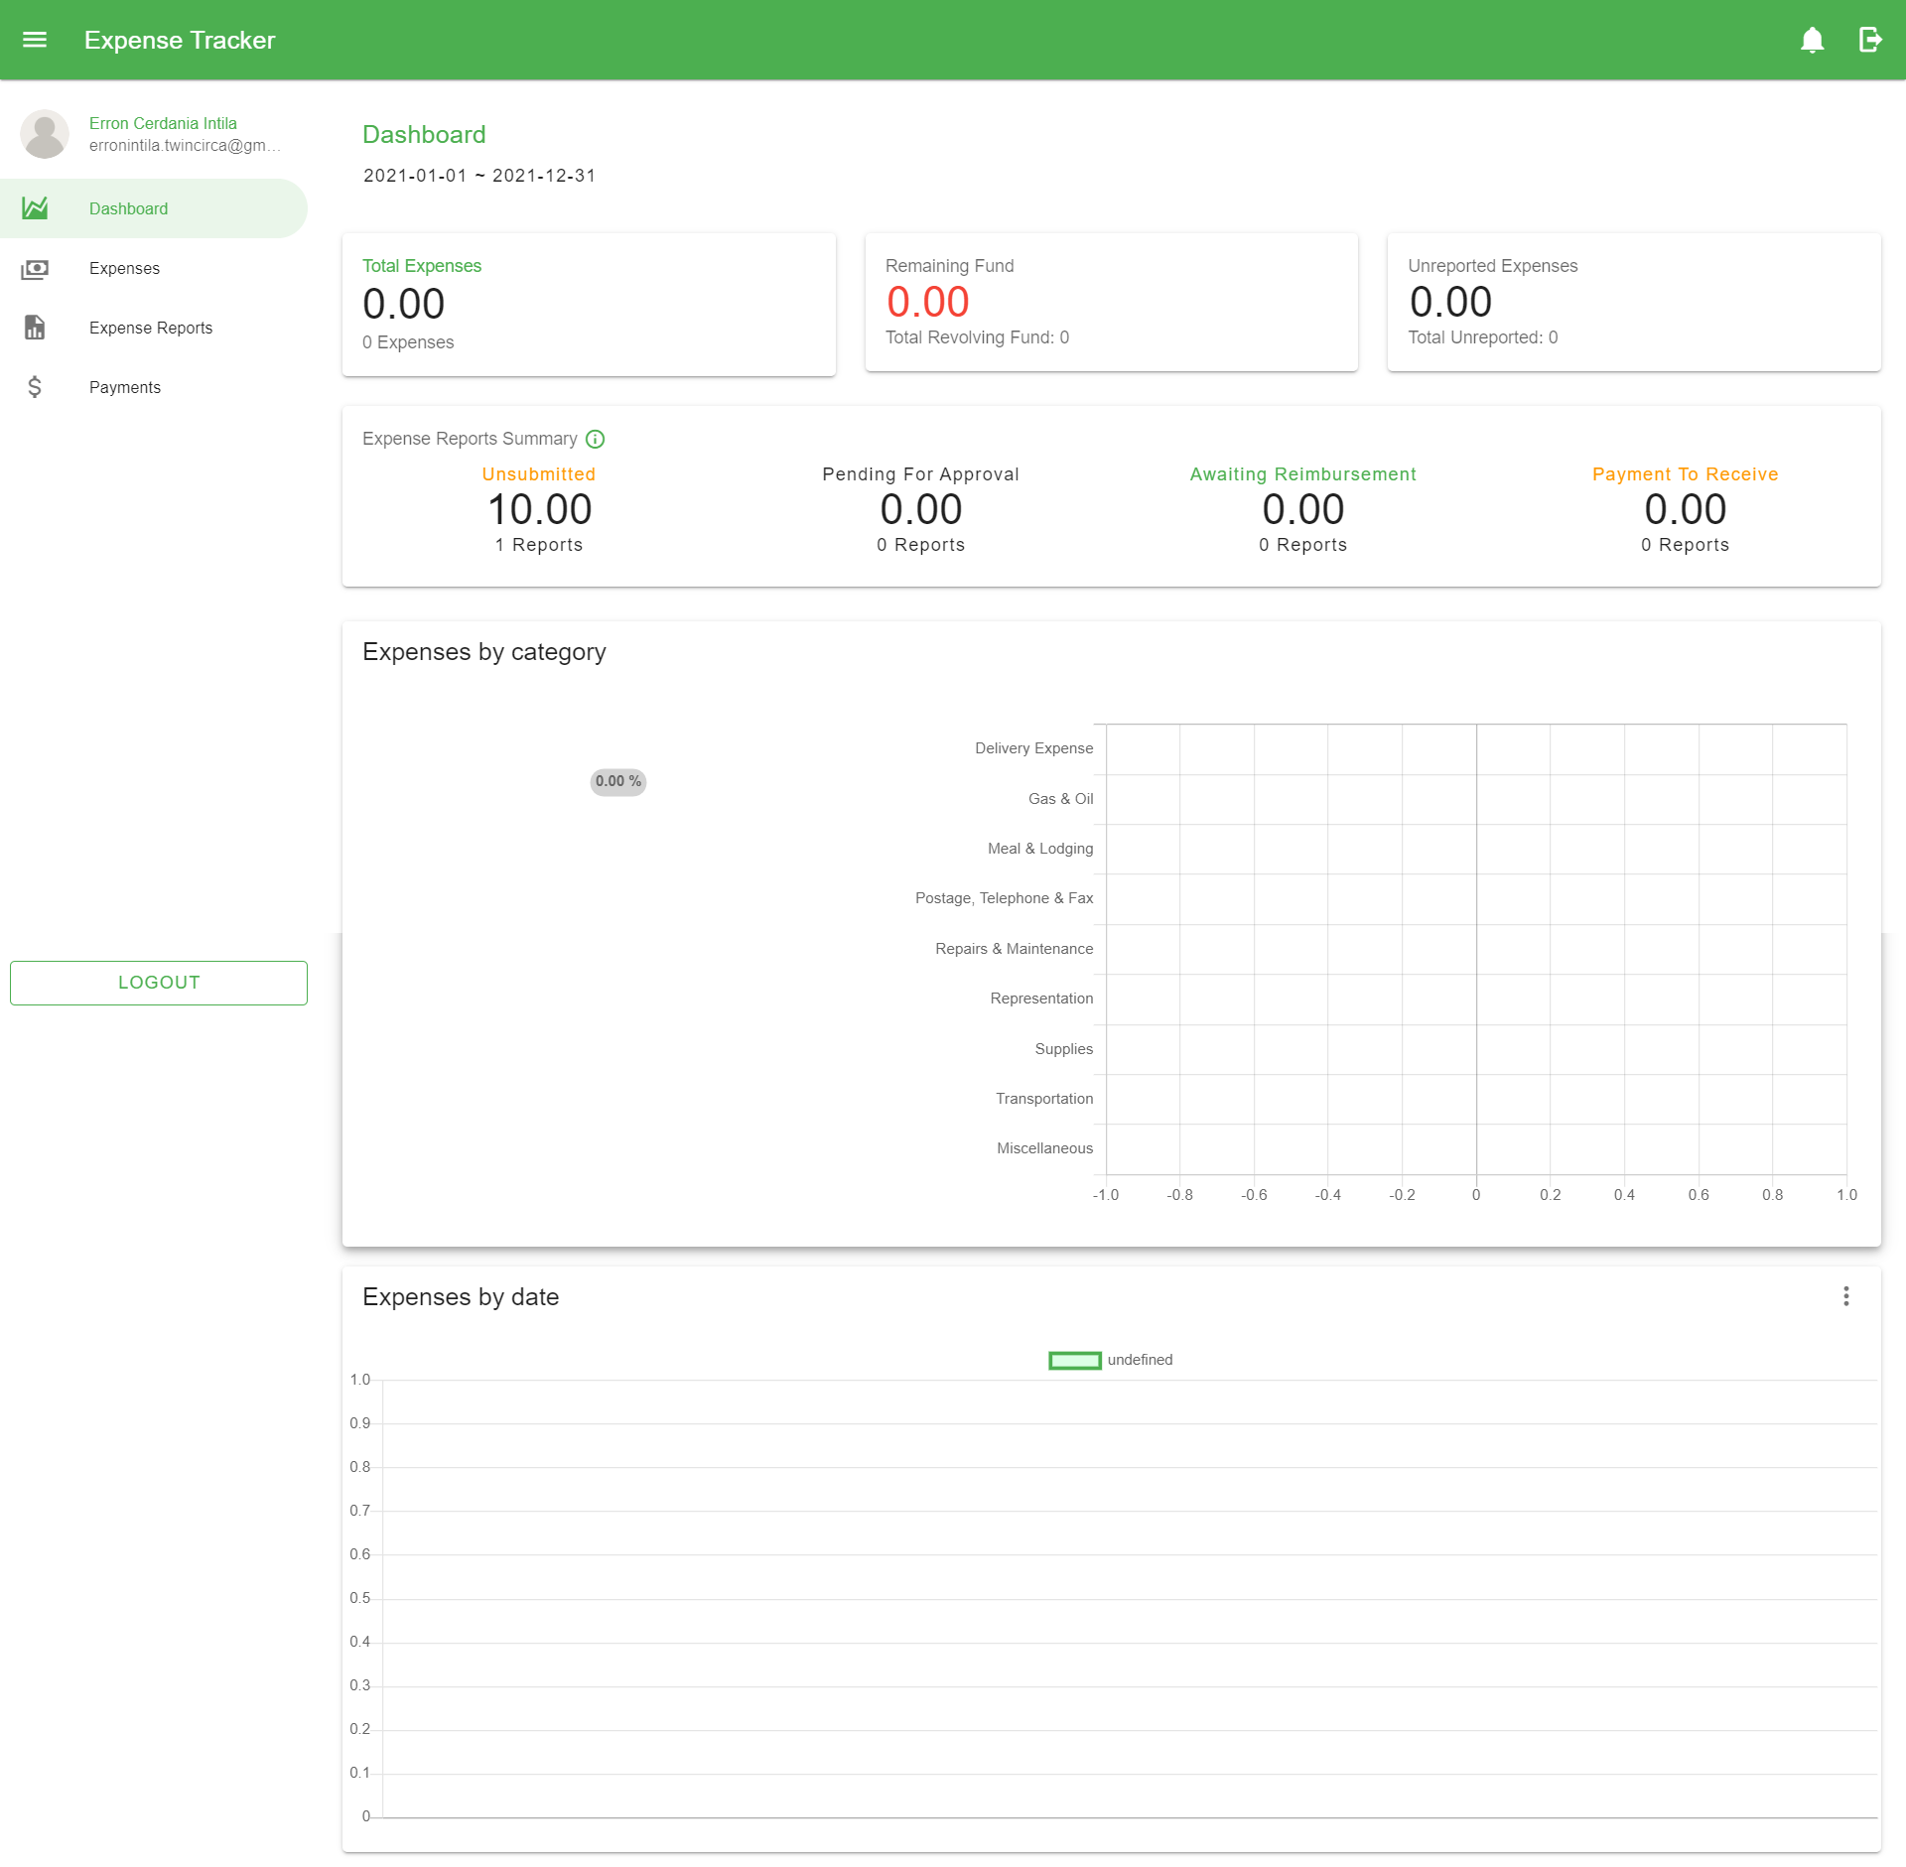

Figure 3 Navigation Drawer

### Footer

The footer is the section of content at the very bottom of the application that provides additional information. It contains a copyright notice and the company name.

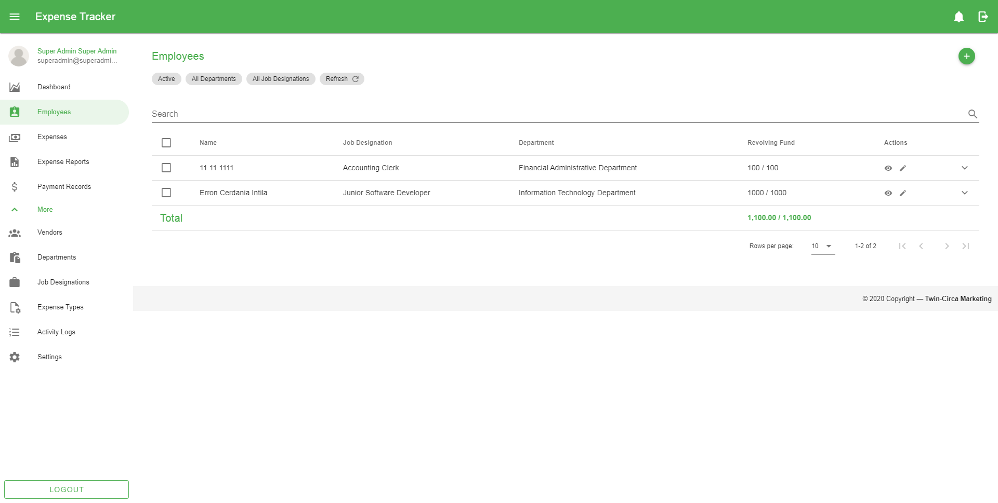

Figure 4 Application footer

## Working with Data Tables

The data tables display a list of information consists of retrieved records from the database depending on the application’s modules.

### Filtering Data Table

The most basic functionality for filtering results is the search using the search bar found on top of every table list. This returns a list of matched records based on the typed characters in the text field.

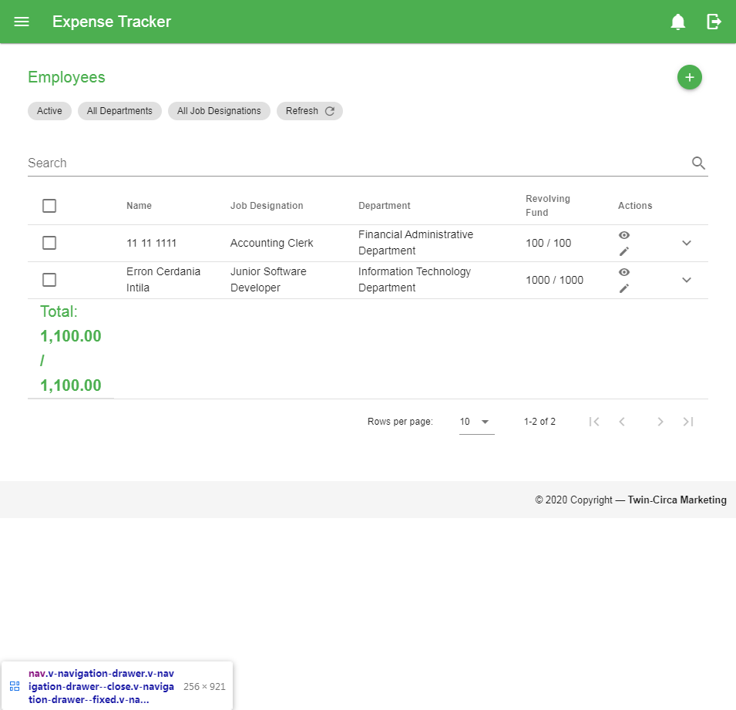

Figure 5 Search bar

Other filter options can be found on top of the search bar of every table list. Some filter options include status (mainly on expenses, reports, and payments including activation status of employees and vendors), selectors for employees, vendors, departments, and job designations. Refer to *Filtering Records* section for more details.

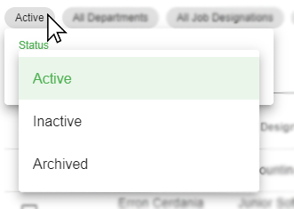

Figure 6 Status filter

### Sorting Data Table

Sorting table data can be done by clicking the column header in the table.

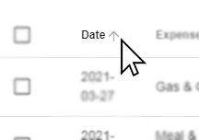

Figure 7 Sorting data table

### Refreshing Data Table

To refresh the records, click the refresh button found on top of the search bar.

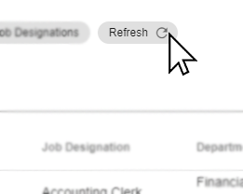

Figure 8 Refresh button

*Note: Clicking the refresh button will refresh/reset selected filters.*

### Showing Additional Row Data

By clicking the dropdown button found on the rightmost part of every row in the table provides more information of a certain row in the table.

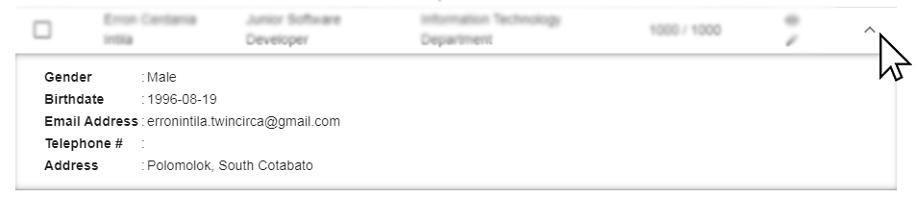

Figure 9 Showing additional row data

### Selecting Rows

To select a certain row, click the checkbox found on leftmost part of every row in the table. The table can handle multiple selection and perform specific actions at once. To select all records, click the first column header with the checkbox and vice-versa.

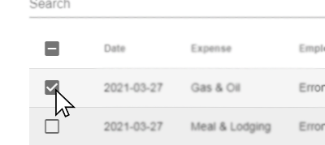

Figure 10 Selecting data table row data

### Perform Actions on Rows

Common action buttons such as show and edit buttons can be found on the right part of every row in the table within the ‘*Actions’* column

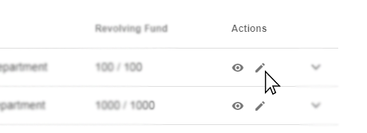

Figure 11 Perform actions on a row data

To perform special actions, additional buttons will be shown on top of the table/search bar after selecting record/s in the table.

### Pagination

Pagination provides a way of separating long sets of data so that it is easier for the user to consume information. This can be found at the bottom of the table. This also consists of a dropdown option for providing how many rows can be displayed on every page.



Figure 12 Pagination

## Filtering Records

Filter options are used to provide a range of data based on supplied criteria, and extracts matching records. These are the common filter options present in different application modules:

### Search Bar

The search bar is commonly used when filtering records particularly on Data Tables found on top of every table list. This returns a list of matched records based on the typed characters in the text field.



Figure 13 Search Bar

### Date Range Picker

Date range picker is used commonly on records that have date associated with it e.g. Expense, Expense Reports, or Payment records. These are the steps to use the filter:

1. Click the Date Range picker (usually found below the page content title) to open the dialog.

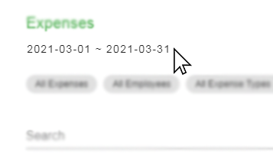

Figure 14 Date Range Picker Button

1. Select the starting and ending dates and click OK to filter.

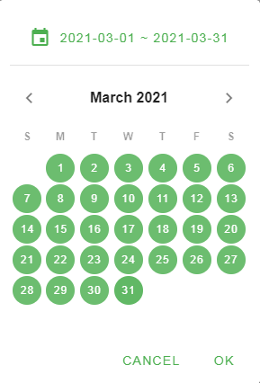

Figure 15 Date Range Picker

### Status Filter

The status filter is used to filter records based on their statuses i.e. Active, Inactive, and Archived. These are the steps to use the filter:

1. Click the ‘Status’ dropdown button usually located at the top of the search bar.

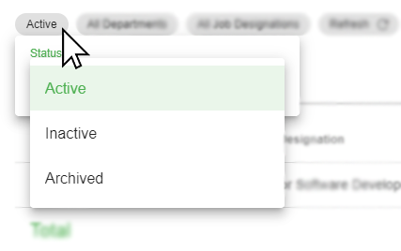

Figure 16 Status Filter

1. Select the status from the options list to filter.

There are other status filters specific only on the records of each application modules. These status filters include:

1. Expense Status Filter

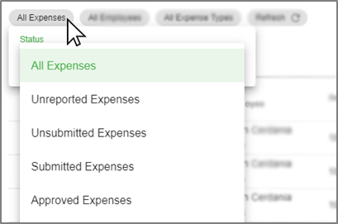

Figure 17 Expense Status Filter

1. Expense Report Status Filter

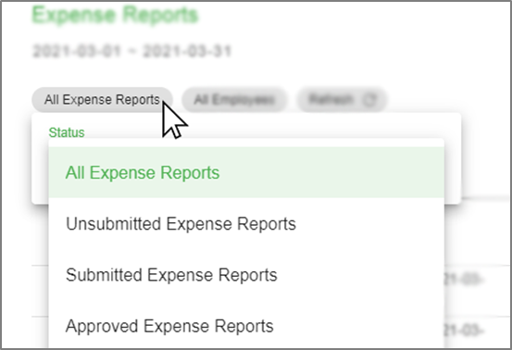

Figure 18 Expense Report Status Filter

1. Payment Status Filter

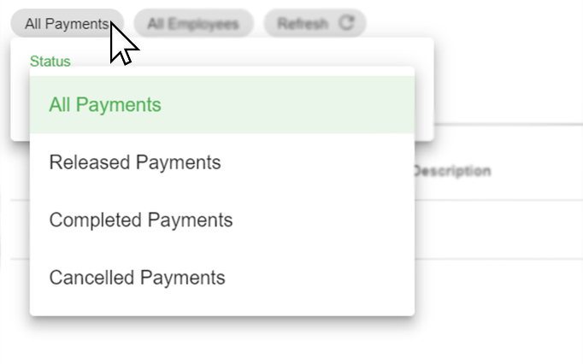

Figure Payment Status Filter

1. Notification Status Filter

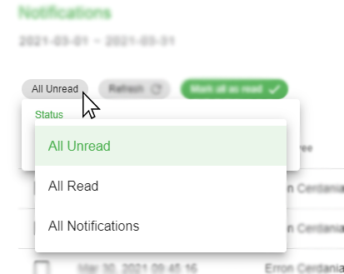

Figure 20 Notification Status Filter

## Access, Authentication, and Authorization

### Signing in to the Application

A user account allows you to sign in to the application. To sign in, go to the login page of the application (http://192.168.1.99:82/login), type in the username and password and click the Login button. Then you will be redirected to the application’s dashboard after a successful login.

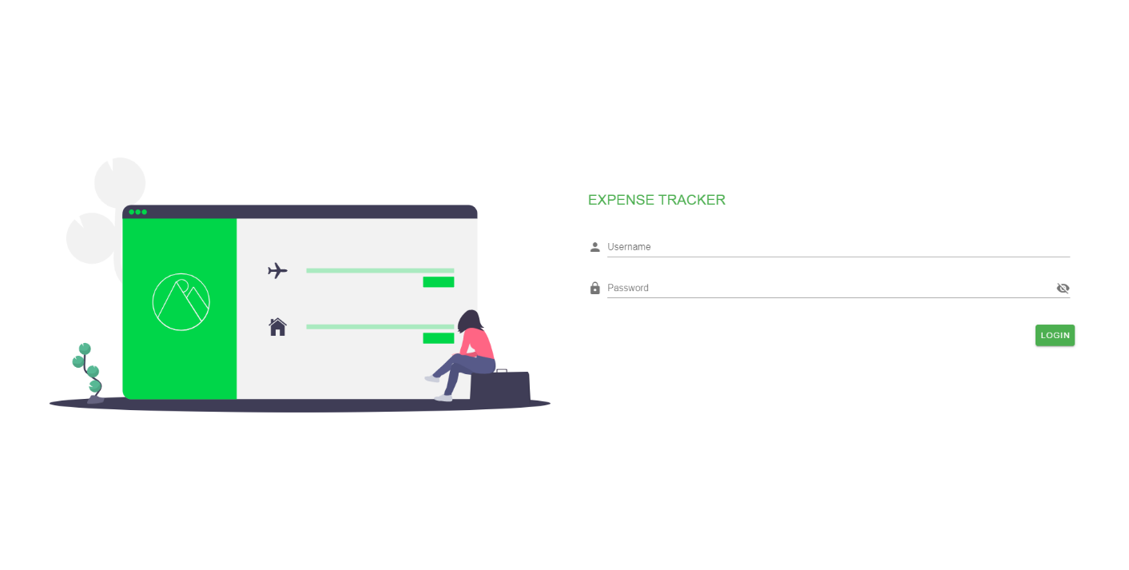

Figure 21 Login page

### Exit the Application

To exit the application, click the logout icon 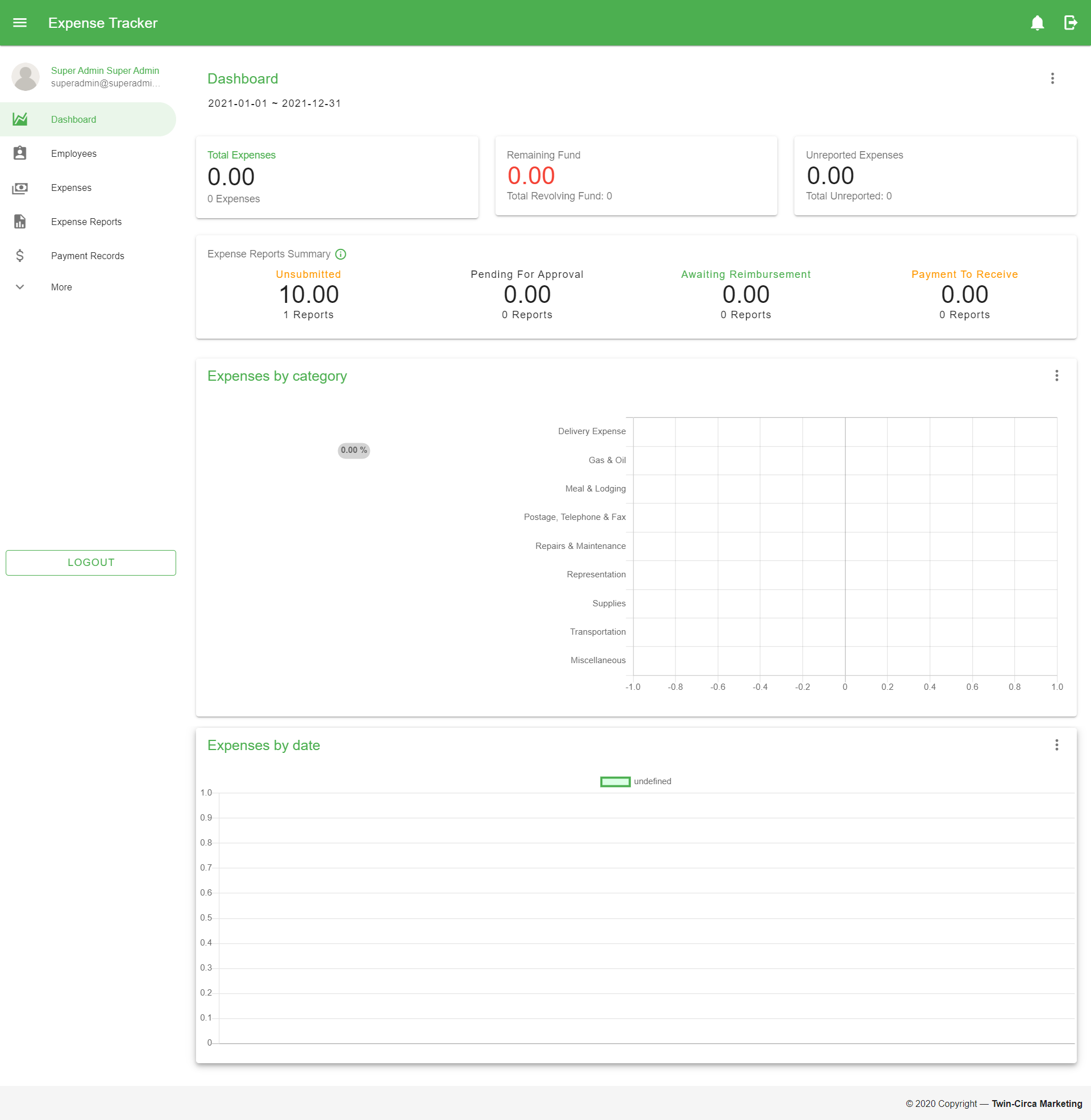 located at the rightmost part of the application bar or select the Logout menu in the Navigation drawer. Then click “Yes” when the dialog appears for confirmation.

# Application Modules

## Dashboard

This module provides graphical representation for data visualization represented by charts and graphs. It consists views of key performance indicators and other information relevant to the company’s employee expense management.

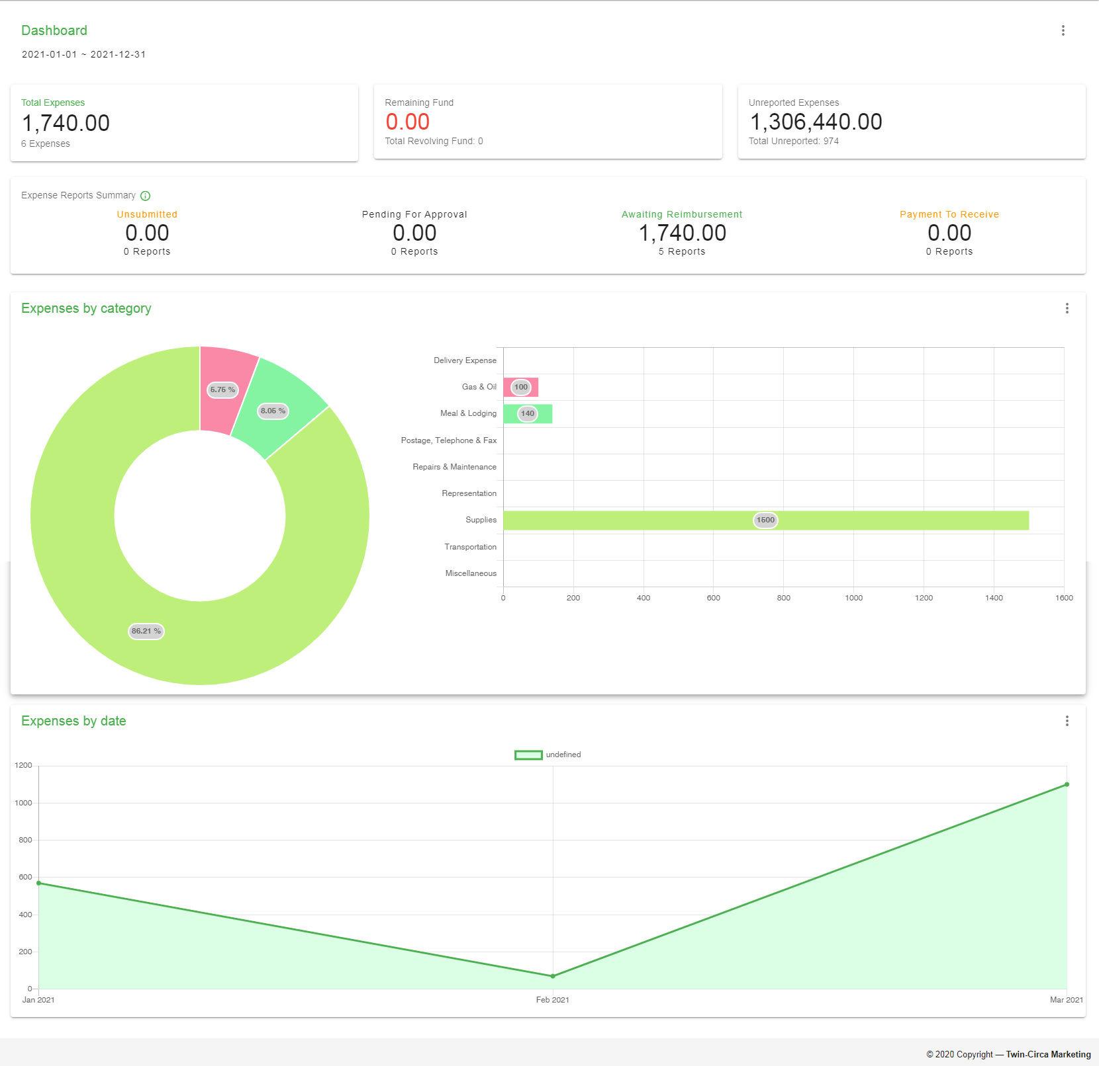

Figure 22 Dashboard

The Dashboard is divided into different sections that provides specific information and graphs to visualize the data represented. These sections are:

### Expense Summary

The expense summary provides information about the overall expenses spent by employees along with remaining fund to monitor and reimburse employees on time.



Figure 23 Expense Summary Dashboard Section

### Expense Reports Summary

The expense reports summary provides information on pending expense reports. This indicates the number and amount of expense reports on each status.



Figure 24 Expense Reports Summary Dashboard Section

This section is divided into four parts which corresponds to different status:

1. Unsubmitted – Created reports that are not yet submitted
2. Pending for Approval – Submitted reports waiting for approval
3. Awaiting Reimbursement – Approved reports waiting for payment
4. Payment to Receive – Reimbursed expenses waiting to be received by the user

### Expense by Category

This section shows a graphical representation of expenses based on categories such as expense types, employees, and departments.



Figure 25 Expense By Category Dashboard Section

### Expense by Date

This section shows a graphical representation of expenses based on date classified into different time units, i.e. day, week, month, quarter, and year.



Figure 26 Expense By date Dashboard Section

### Filtering Records

To filter records on different sections of the Dashboard, click the  icon located at the top-right of every section to show the list of filters that can be applied. All data represented by default is based on the current year except for the Expense Reports Summary section. To filter the overall Dashboard data by date, click the date picker located below the Page Content title, refer to the image shown below:

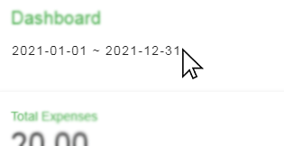

Figure 27 Dashboard Date filter

## Profile

This module is a record of personal, user-specific data associated with the user's identity. This also includes settings for updating personal and account information. This mainly contains the profile card located at the left part, and at the right part of the page, shows a form for updating information.

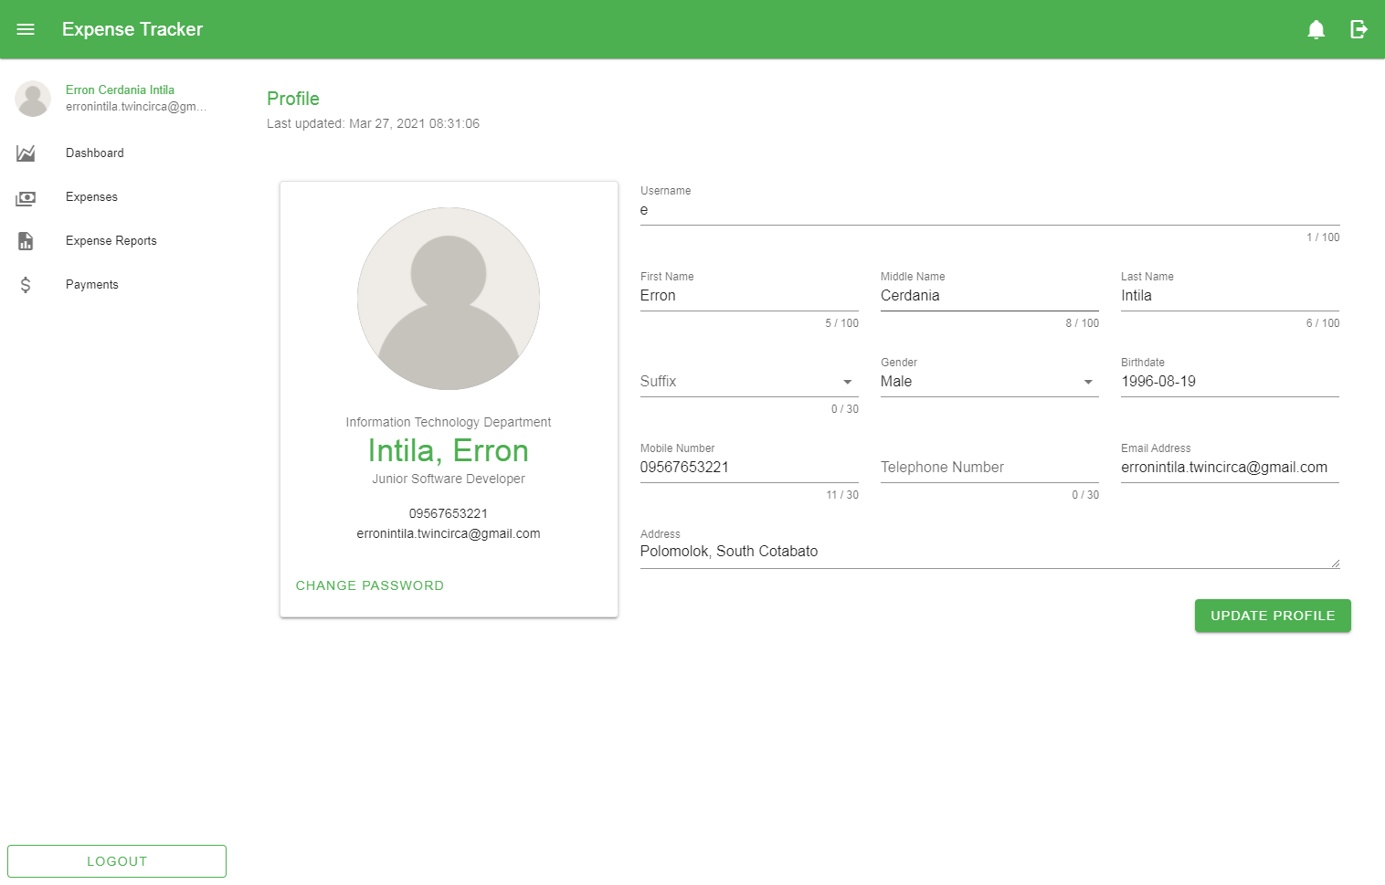

Figure 28 User Profile

### Updating Information

To update the information, fill in or change the information in the form fields and click the *‘Update Profile’* button at the bottom.

### Change Password

In changing the password, click the ‘*Change Password’* button located at the bottom part of the Profile Card to open the form and fill in the required details.

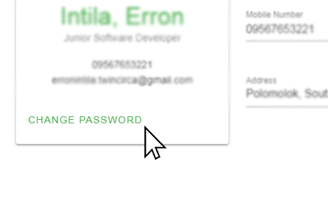

Figure 29 Change Password Button

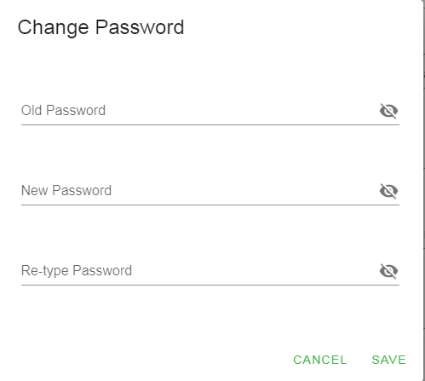

Figure 30 Change Password Form

The form contains the following:

1. Old Password – This is used to check if the user of the account is the actual user changing the password.
2. New Password – This field holds the information to update the old password.
3. Retype Password – This is used for password confirmation if the new password is typed in correctly.

*Note: If the user forgot the password, make a request to the administrator to reset the account password.*

## Expense

This module involves management of each employee expenses. This allows the user to view, add, edit, and cancel expenses depending on the user role and level of permissions given.

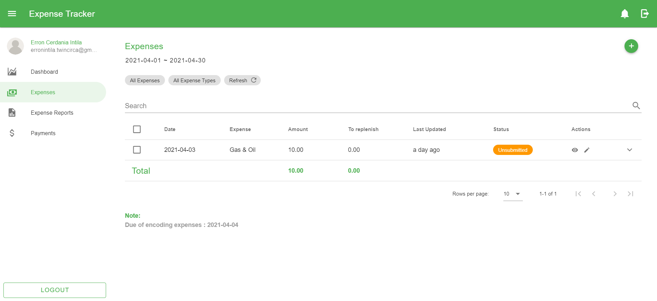

Figure 31 Expense Page

### Creating New Expense

These are the following steps in creating a new expense:

1. Go to the Expense page by navigating through the navigation drawer and click the Expenses menu.
2. In the Expense page, click the Add button located at the top-right corner of the page content.
3. Fill in the following details based on the image shown below.

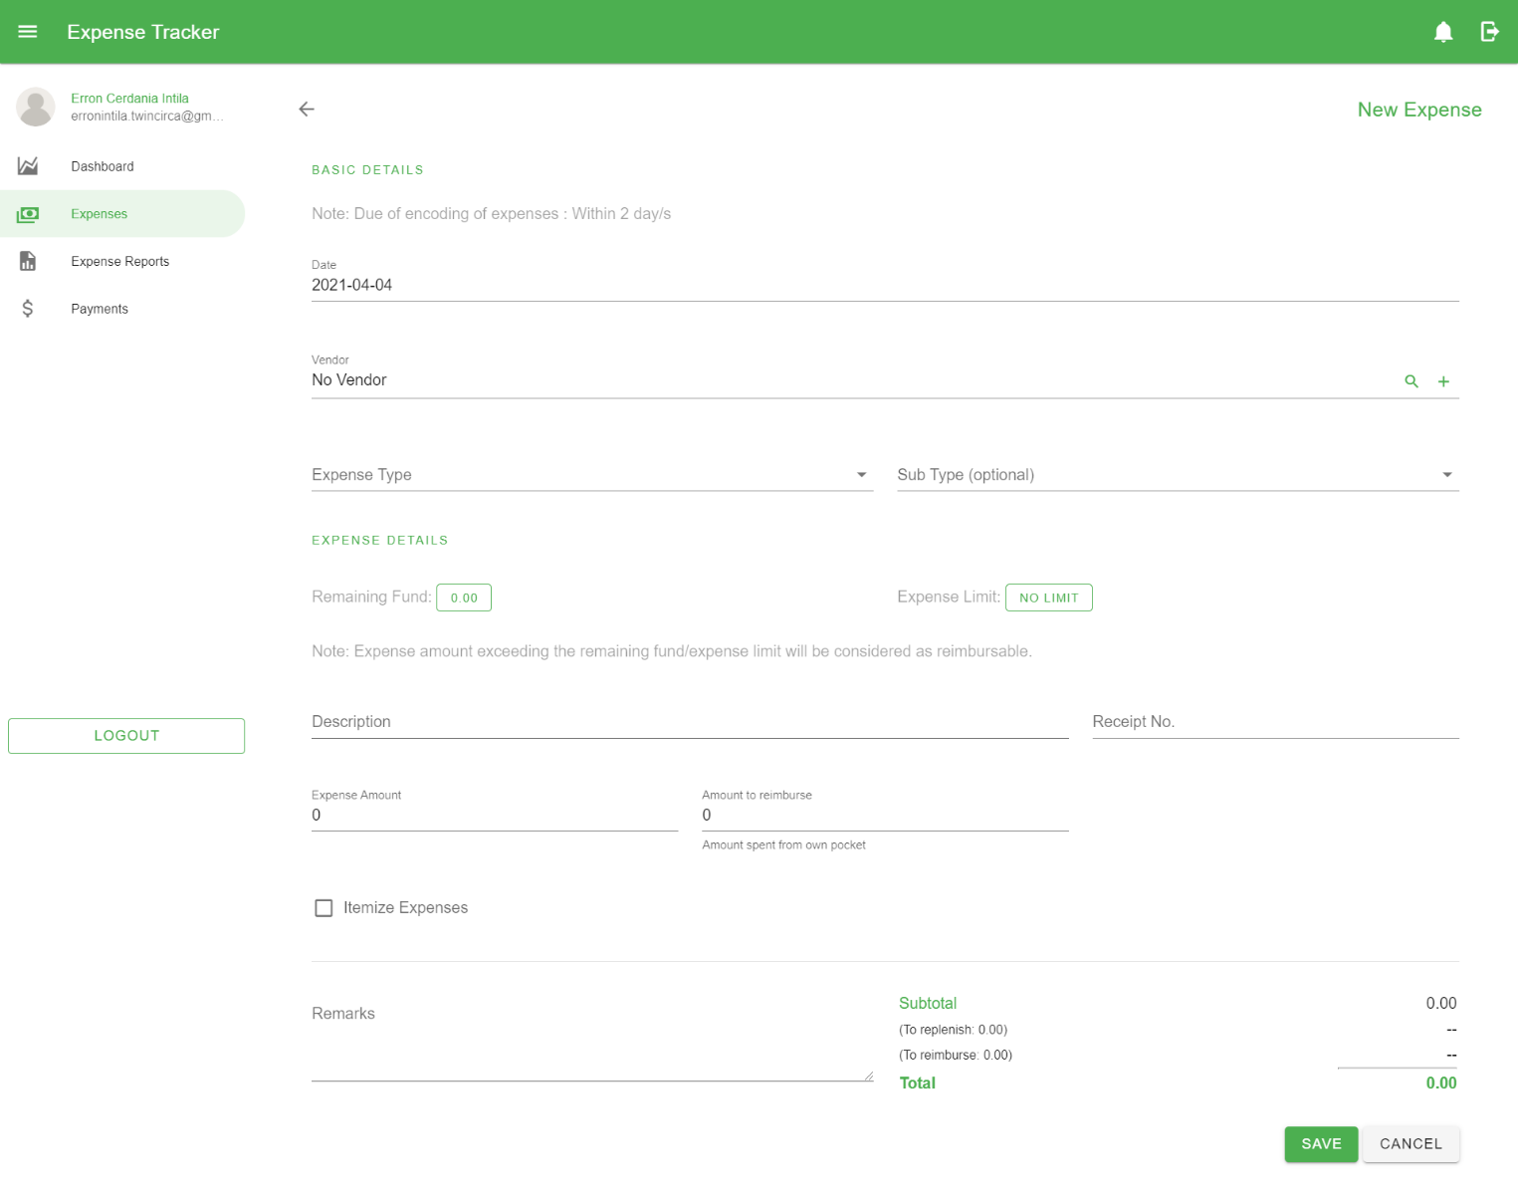

Figure 32 Create Expense Form

These are the following fields in the form:

* 1. *Date* – the date of the expense
  2. *Vendor* – the person or business entity of which expenses have been incurred
  3. *Expense Type* – a classification of the expense
  4. *Sub Type* – a more detailed classification of the expense
  5. *Description* – used to describe what the expense is all about
  6. *Receipt No.* – a unique case number found in receipts
  7. *Expense Amount* – amount that an employee incurs
  8. *Amount to reimburse* – the amount of which the employee used to pay expenses on behalf of the company
  9. *Itemized Expenses* – a more detailed information of an expense

Check the *‘Itemize Expense’* checkbox to display the itemized expense table and action button for adding expenses.

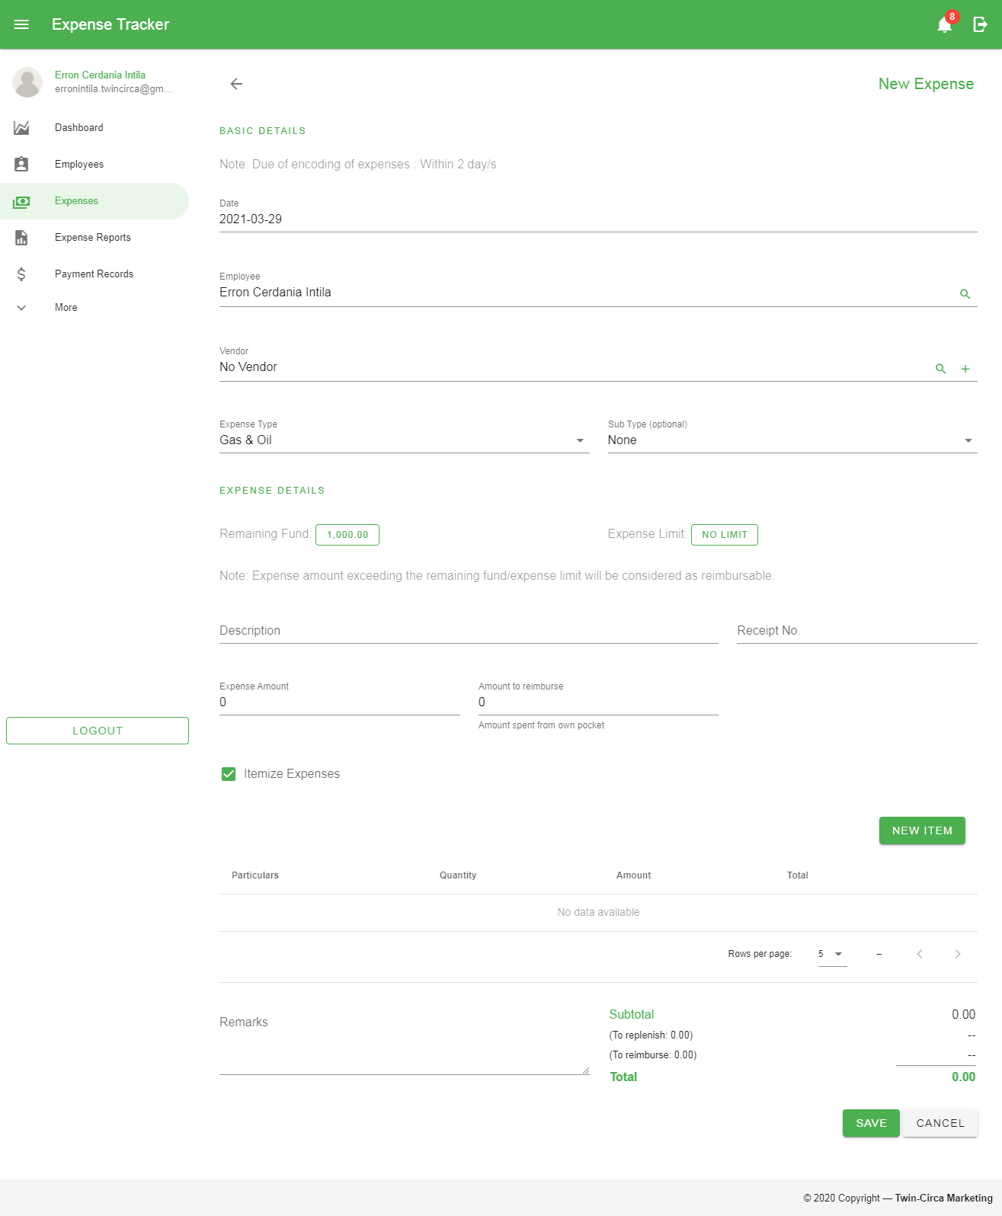

Figure 33 Itemized Expenses Table

When adding new record, click the *‘New Item’* button to open the form. Fill in the details needed to add new expense. Then click the ‘*Add’* button to add it on the table.

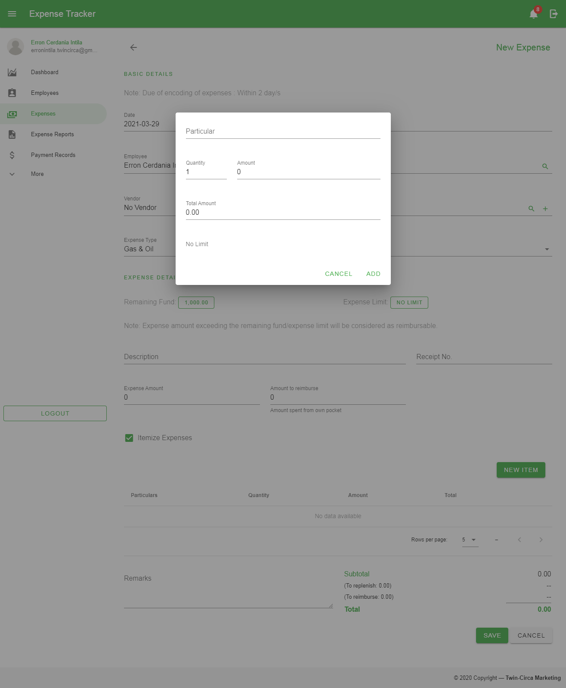

Figure 34 Add Expense Form for Itemized Expenses Record

* 1. *Remarks* – additional information of the expense record that needed to be taken into consideration

1. Click the *‘Save’* button located at the bottom of the page.

*Note: In creating expenses, the date of the expense must be in accordance with the allowed encoding period set by the administrator. In order to create expense records beyond the limit, make a request to the administrator for permission.*

### Editing Expense

These are the following steps in editing an expense:

1. In the Expense Page, click the Edit button 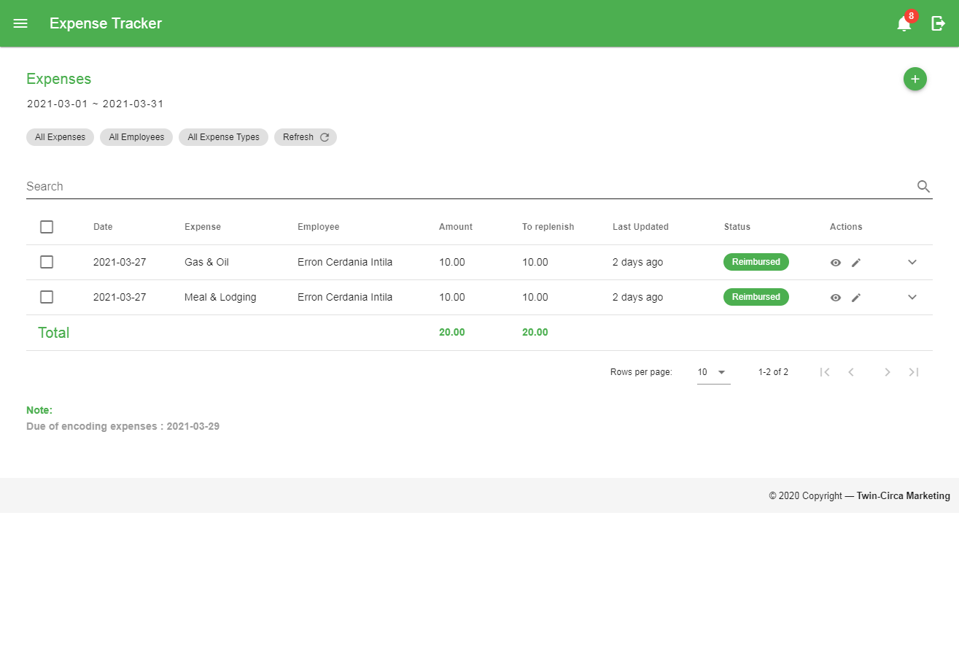 in a particular row in the data table located within the Action column to go to the Edit Page.
2. Fill in the details to be updated.
3. Click the Save button located at the bottom of the page.

*Note: Expenses can only be edited if the record has not been associated with any expense report. All expenses with an unapproved report can also be edited.*

### Expense Status

These are the statuses used to label every expense record:

1.  – Expenses that are not associated with any Expense Report.
2.  – Created Expenses that are not yet submitted.
3.  – Submitted Expenses waiting for approval.
4.  – Approved Expenses ready for reimbursement.
5.  – Rejected Expenses which considered as unapproved records accompanied with reason.
6.  – Cancelled Expenses considered as a deleted record.
7.  - Expenses associated with payment record but not yet confirmed.
8.  – Expenses with complete transaction wherein reimbursement process is complete.

### Viewing Expense

To view a specific record, click the Show button 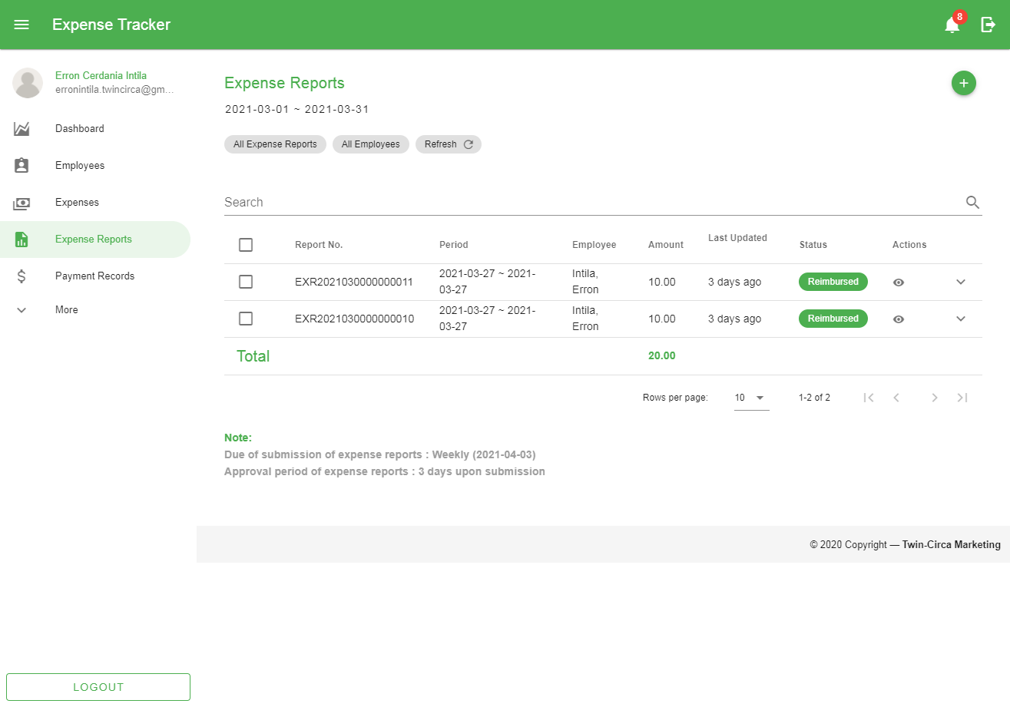 in a particular row in the data table located within the Action column to go to the View Expense page for a more detailed information.

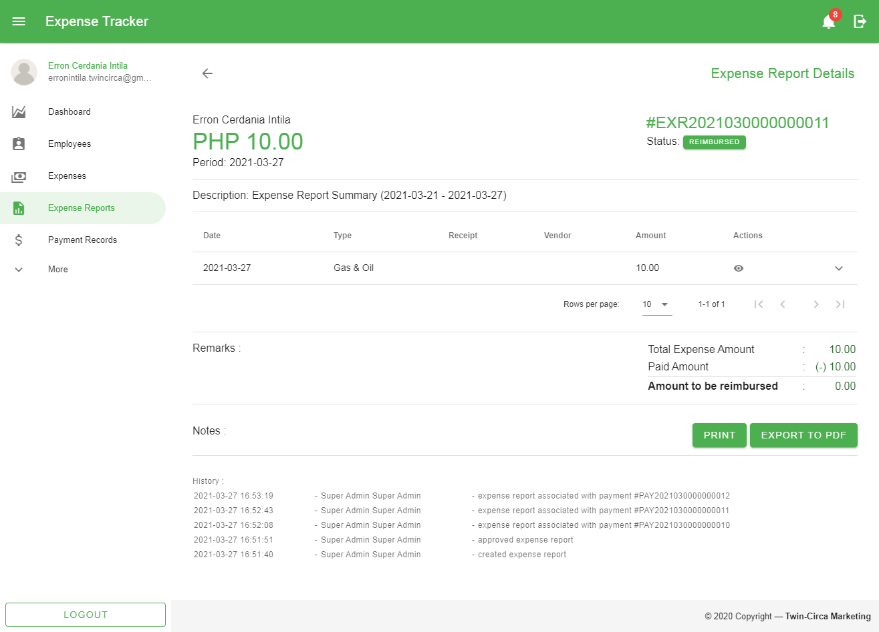

Figure 35 View Expense Page

### Cancelling Expenses

These are the following steps in cancelling an expense:

1. Select the expense record by checking the checkbox in the first column of the data table.
2. Click the *‘Cancel Expenses’* button shown above the Search bar along with other filter options.

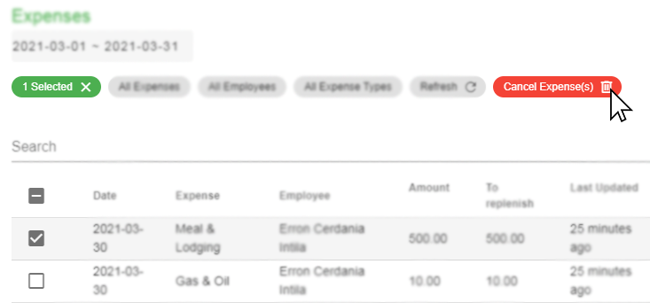

Figure 36 Cancelling Expenses

1. Click the *‘Yes’* button in the popup dialog to confirm the action.

### Restoring Expenses

These are the following steps in restoring an expense:

1. Filter the records through the Status filter located at the top of the search bar and select *‘Cancelled Expenses’*.
2. Select the expense record by checking the checkbox in the first column of the data table.
3. Click the ‘Restore Expenses’ button shown above the Search bar along with other filter options.

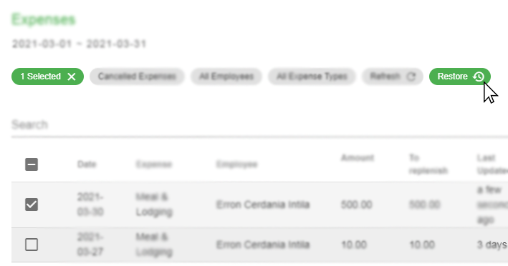

Figure 37 Restoring Expenses

1. Click the *‘Yes’* button in the popup dialog to confirm the action.

*Note: Cancelling and restoring expenses can only be done if the existing record has not been associated with any expense report.*

## Expense Report

This module allows the user to manage created expenses grouped into reports. This involves creation, submission, approval, rejection and cancellation of records. Each record has specific status used mainly for monitoring with regards to employee reimbursement.

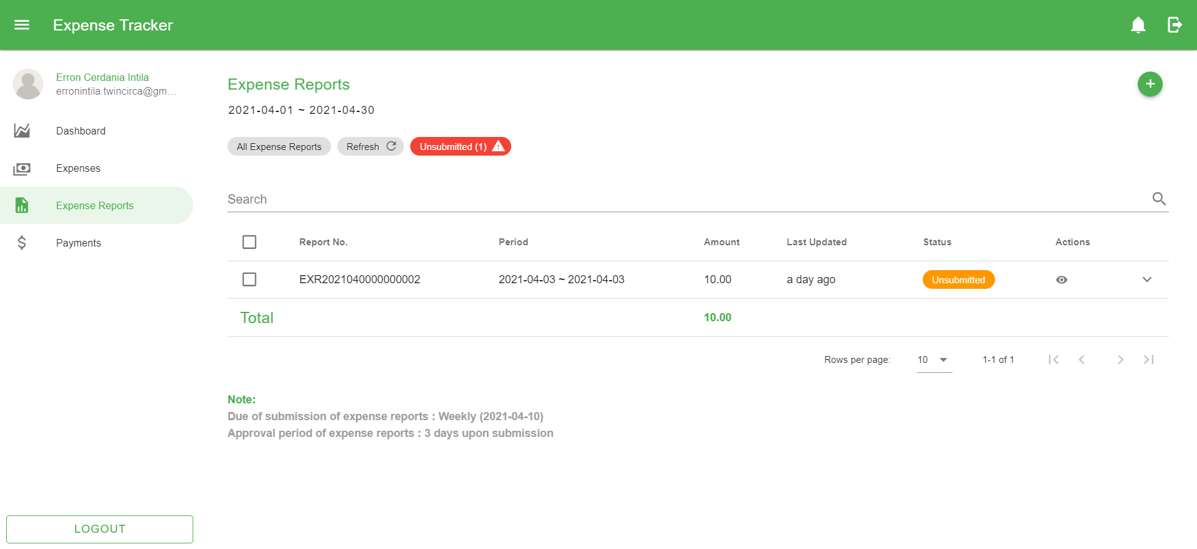

Figure 38 Expense Report Page

### Creating New Expense Report

These are the steps in creating new report:

1. Go to the Expense Report page by navigating through the navigation drawer. Then click the Expense Report menu.
2. In the Expense Report page, click the ‘*Add’* button located at the top-right corner of the page content.
3. Fill in the following details based on the image shown below.

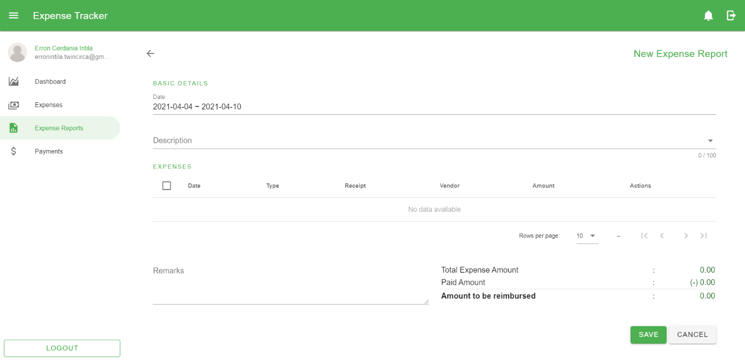

Figure 39 Expense Report Add Form

These are the following fields in the form:

* 1. *Date* – this is a date range picker used to filter the expenses needed to be retrieved and use within the report
  2. *Description* – describes the content of the report
  3. *Expenses List* – the list of expenses retrieved based on the selection using the date range picker

To add expenses that will be included in the report, select from the list of records by clicking the checkboxes in the first column of the data table.

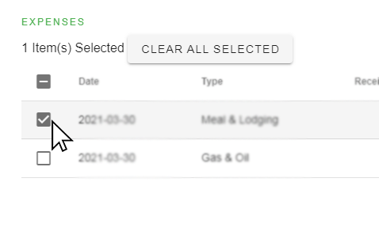

Figure 40 Selecting expenses for Expense Report

* 1. *Remarks* – additional information of the record that needed to be taken into consideration

1. Click the *‘Save’* button located at the bottom of the page.

### Editing Expense Report

These are the steps in editing an expense report:

1. In the Expense Report Page, click the Edit button  in a particular row in the data table located within the Action column to go to the Edit Page.
2. Fill in the details to be updated.
3. Click the Save button located at the bottom of the page.

*Note: Expense Reports can only be edited if the record has not been approved. Expense Reports with an approved status without any association with a payment record can only be edited by the administrator.*

### Viewing Expense Report

To view a specific record, click the Show button  in a particular row in the data table located within the Action column to go to the View Expense Report page for a more detailed information.

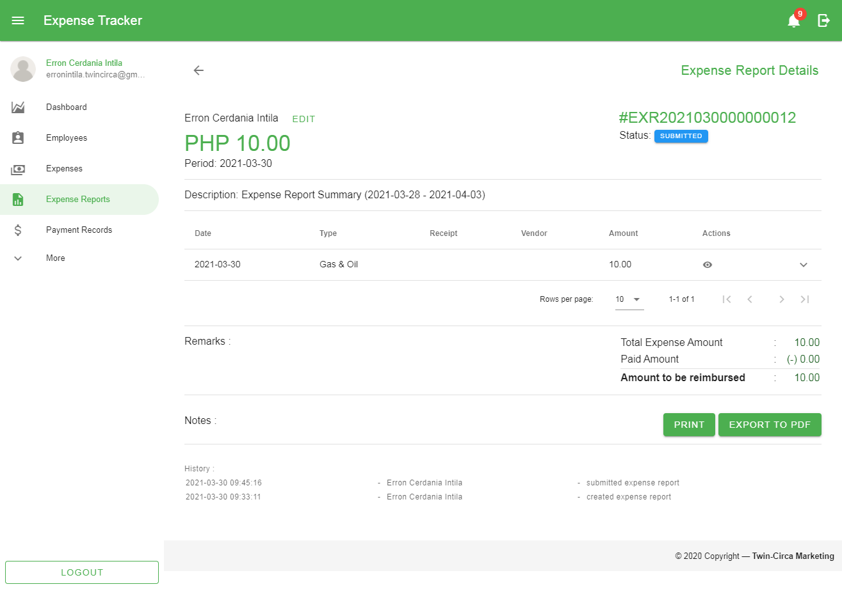

Figure 41 View Expense Report Page

### Expense Reports Status

These are the statuses used to label every expense report:

1.  – Created Expense Reports that are not yet submitted.
2.  – Submitted Expense Reports waiting for approval.
3.  – Approved Expense Reports ready for reimbursement.
4.  – Rejected Expense Reports which considered as unapproved records accompanied with reason.
5.  – Cancelled Expense Report considered as a deleted record.
6.  - Expense Reports associated with payment record but not yet confirmed.
7.  – Expense Reports with complete transaction wherein reimbursement process is complete.

### Submitting Expense Reports

These are the steps in submitting an expense report:

1. Select the record/s by checking the checkbox in the first column of the data table.
2. Click the ‘Submit’ button shown above the Search bar along with other filter options.

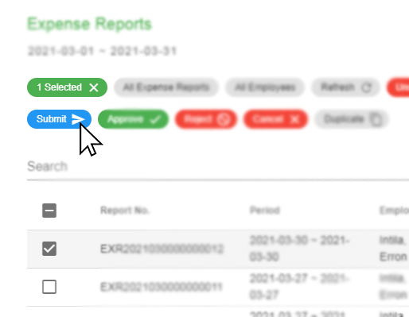

Figure 42 Submitting Expense Reports

1. Click the ‘Yes’ button in the popup dialog to confirm the action.

*Note: In submitting expense reports, the starting date of the expenses belong to the report must be in accordance with the allowed submission period set by the administrator. In order to submit records beyond the limit, make a request to the administrator for permission.*

### Printing and Exporting Expense Reports

In order to print the expense report, the record must be submitted first. The following steps include:

1. Select the record by checking the checkbox in the first column of the data table.
2. Click the ‘Print’ or ‘Export’ dropdown button shown below the data table.

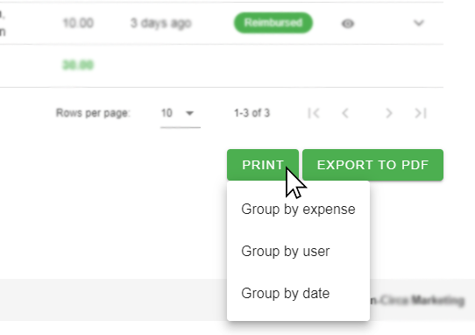

Figure 43 Printing/Exporting Expense Reports

The printing/exporting the selected record/s have three format:

* 1. Group by expense – The expenses of selected report/s are grouped by expenses along with their expense types.
  2. Group by user – The expenses of selected report/s are grouped by system users/employees.
  3. Group by date – The expenses of selected report/s are grouped based on expenses’ dates.

### Cancelling Expense Reports

These are the steps in cancelling expense report/s:

1. Select the record/s by checking the checkbox in the first column of the data table.
2. Click the ‘Cancel’ button shown above the Search bar along with other filter options.

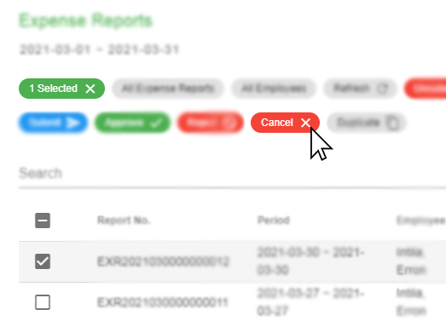

Figure 44 Cancelling Expense Reports

1. Click the ‘Yes’ button in the popup dialog to confirm the action.

### Duplicating Expense Reports

These are the steps in duplicating an expense report:

1. Select the record/s by checking the checkbox in the first column of the data table.
2. Click the ‘Duplicate’ button shown above the Search bar along with other filter options.

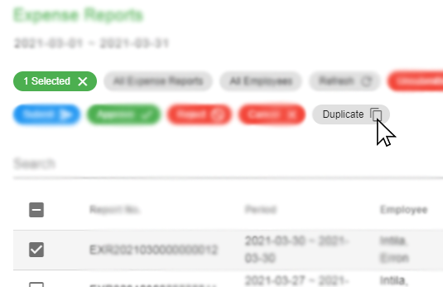

Figure 45 Duplicating Expense Reports

1. Click the ‘Yes’ button in the popup dialog to confirm the action.

*Note: Duplicating expense reports will go back to unsubmitted status. Expenses from the referenced expense report are also duplicated.*

## Payment

This module provides record of payments for approved expense reports. This also shows status of transaction whether a certain payment has been created or received by the employee.

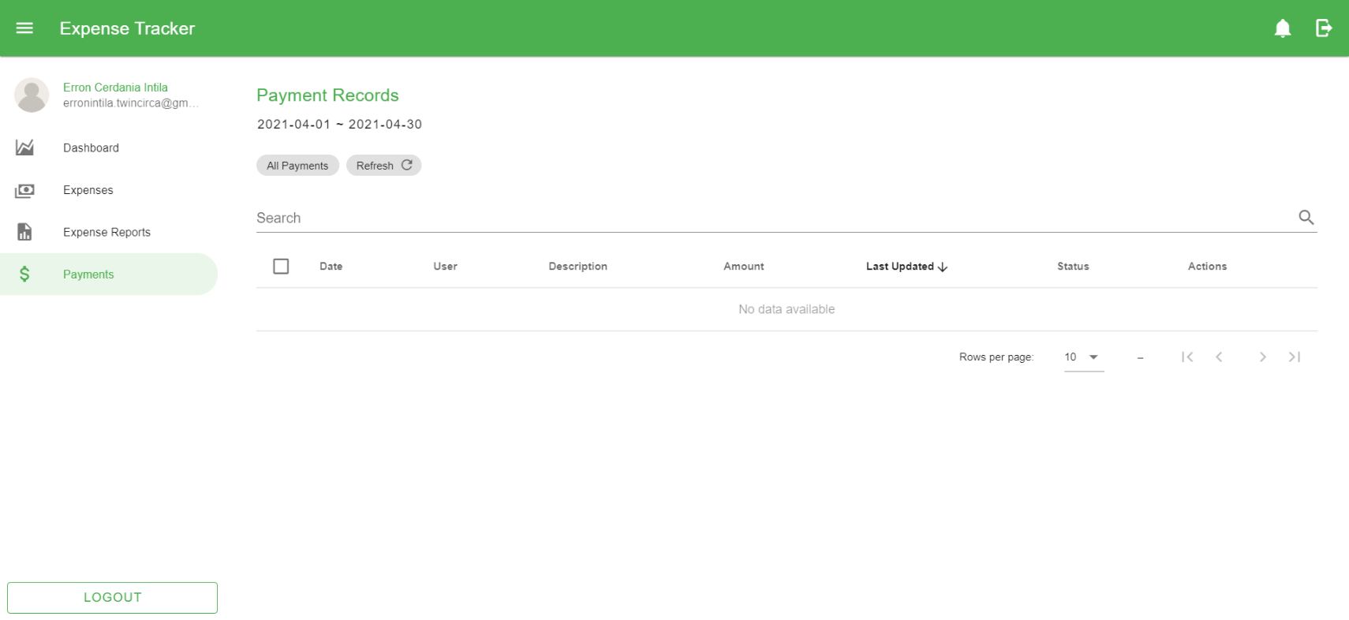

Figure 46 Payment Record Page

### Viewing Payment Record

To view a specific record, click the Show button  in a particular row in the data table located within the Action column to go to the View Payment page for a more detailed information.

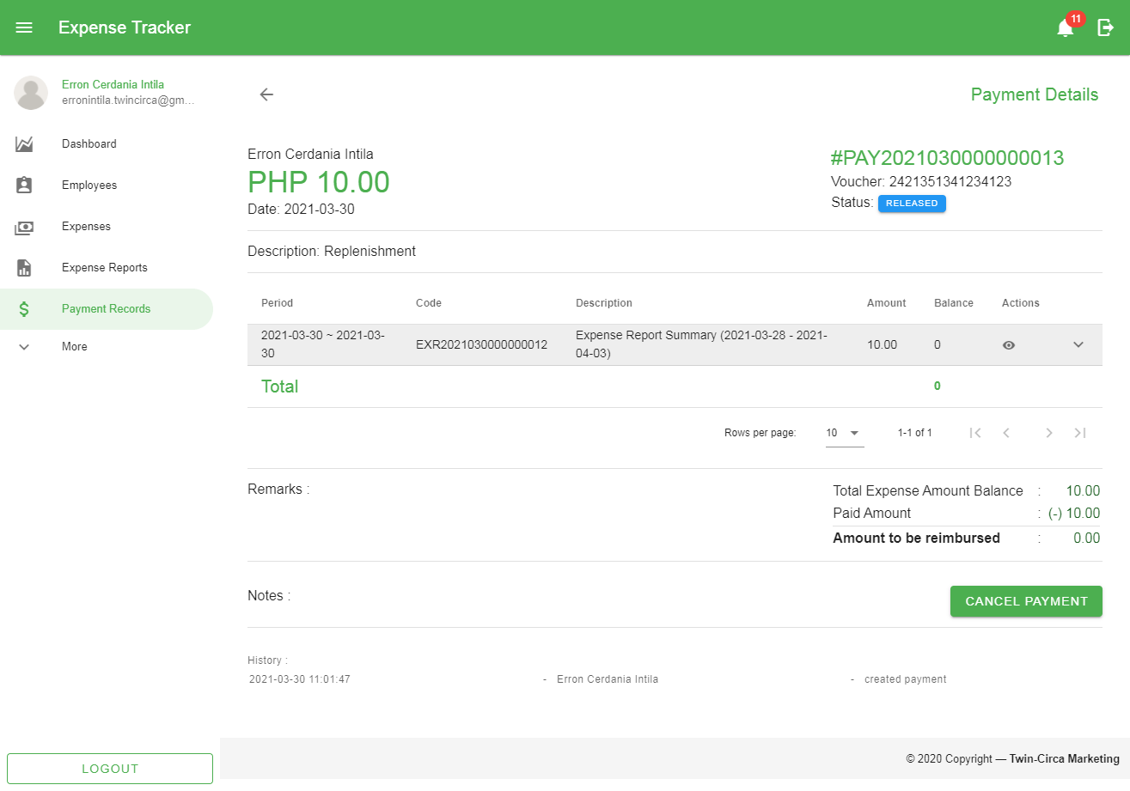

Figure 49 View Payment Page

### Payment Record Status

These are the statuses used to label every payment record:

1.  - Used to label payment after recorded in the application.
2.  - Payment has been confirmed and reimbursement process is complete.
3.  - Cancelled payment records

### Confirming Payment Records

After creating payment record for expense report/s, confirming payment is required to complete the reimbursement process. The confirmation means that the payment has been received and is done by the employee associated with the reimbursed expenses. The following steps are:

1. Select the record/s by checking the checkbox in the first column of the data table.
2. Click the ‘Mark as Received’ button shown above the Search bar along with other filter options.

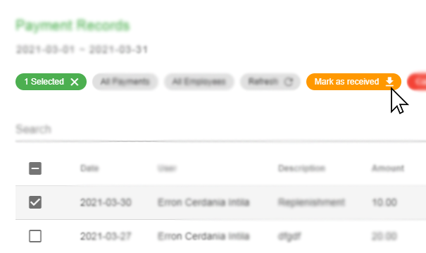

Figure 50 Marking Payment as Received

1. Click the ‘Yes’ button in the popup dialog to confirm the action.

## Notifications

This module provides a message that appears on the right side of the application. This is a way to let the user know that something new has happened within the application (e.g. submitting expense report) to avoid missing transactions that might be worth the attention of the user and appears whether the user is using the application or not.

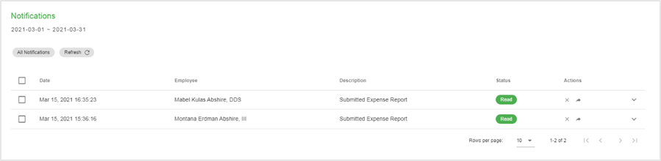

Figure 86 Notifications Page

### Viewing Notifications

These are the steps when viewing notifications:

1. Go to the Notification page by navigating through the application bar and click the Notification icon to open the Notification drawer.



Figure 87 Notification Icon

1. In the Notification Drawer, click View All to go to the Notification page.

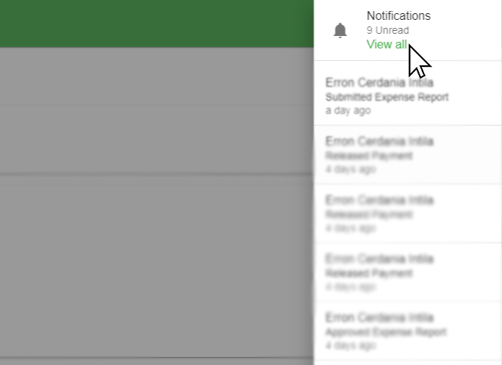

Figure 88 Notification Drawer

### Changing Notification Status

#### Mark All as Read

These are the steps when marking all the notifications as read:

1. In the Notification page, click the Mark All as Read button shown above the data table.

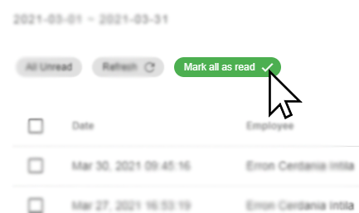

Figure 89 Marking All Notifications as Read

#### Mark as Read

These are the steps when marking notifications as read:

1. In the Notification Page, the default shows all the unread notifications. You can also filter the records through the Status filter located at the top of the search bar and select ‘All Notifications’ to show as well the read notifications.
2. Select the record/s by checking the checkbox in the first column of the data table.

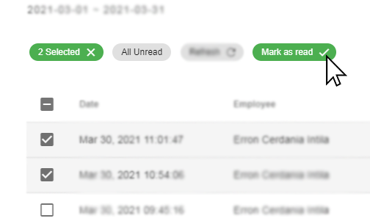

Figure 90 Marking Notifications as Read

1. Click the ‘Mark as Read’ button shown above the Search bar along with other filter options.

#### Mark as Unread

These are the steps when marking notifications as read:

1. Filter the records through the Status filter located at the top of the search bar and select ‘All Read’.
2. Select the record/s by checking the checkbox in the first column of the data table.

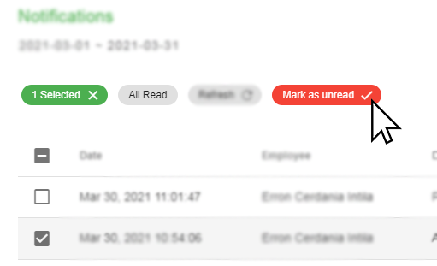

Figure 91 Marking Notifications as Unread

1. Click the ‘Mark as Unread’ button shown above the Search bar along with other filter options.

# Appendices

## Figures

Figure 1 Application Bar 3

Figure 2 Page Content 4

Figure 3 Navigation Drawer 5

Figure 4 Application footer 5

Figure 5 Search bar 6

Figure 6 Status filter 6

Figure 7 Sorting data table 6

Figure 8 Refresh button 7

Figure 9 Showing additional row data 7

Figure 10 Selecting data table row data 7

Figure 11 Perform actions on a row data 8

Figure 12 Pagination 8

Figure 13 Search Bar 9

Figure 14 Date Range Picker Button 9

Figure 15 Date Range Picker 10

Figure 16 Status Filter 10

Figure 17 Expense Status Filter 11

Figure 18 Expense Report Status Filter 11

Figure 19 Payment Status Filter 11

Figure 20 Notification Status Filter 12

Figure 21 Login page 13

Figure 22 Dashboard 14

Figure 23 Expense Summary Dashboard Section 15

Figure 24 Expense Reports Summary Dashboard Section 15

Figure 25 Expense By Category Dashboard Section 15

Figure 26 Expense By date Dashboard Section 16

Figure 27 Dashboard Date filter 16

Figure 28 User Profile 17

Figure 29 Change Password Button 17

Figure 30 Change Password Form 18

Figure 31 Expense Page 19

Figure 32 Create Expense Form 20

Figure 33 Itemized Expenses Table 21

Figure 34 Add Expense Form for Itemized Expenses Record 21

Figure 35 View Expense Page 22

Figure 36 Cancelling Expenses 23

Figure 37 Restoring Expenses 23

Figure 38 Expense Report Page 25

Figure 39 Expense Report Add Form 26

Figure 40 Selecting expenses for Expense Report 26

Figure 41 View Expense Report Page 27

Figure 42 Submitting Expense Reports 28

Figure 43 Printing/Exporting Expense Reports 29

Figure 44 Cancelling Expense Reports 30

Figure 45 Duplicating Expense Reports 30

Figure 46 Payment Record Page 31

Figure 49 View Payment Page 32

Figure 50 Marking Payment as Received 33

Figure 86 Notifications Page 34

Figure 87 Notification Icon 34

Figure 88 Notification Drawer 34

Figure 89 Marking All Notifications as Read 35

Figure 90 Marking Notifications as Read 35

Figure 91 Marking Notifications as Unread 36

Figure 93 403 Forbidden Page 40

Figure 94 404 Not Found Page 40

Figure 95 500 Internal Server Error Page 41

Figure 96 503 Service Unavailable 41

## Troubleshooting

### Software Troubleshooting

#### Unable to Access the Application

* Check if the network cable is connected to the PC.
* Check the browser’s address bar if the URL is correct (*http://192.168.1.99:82/*)
* If the above recommendation were performed but problem still persist, please contact the helpdesk/technician for support.

#### Unable to Sign in to the Application

* + Make sure to enter correct username and password.
* If the above recommendation were performed but problem still persist, please contact the helpdesk/technician for support.

#### Unable to Print the Expense Report

* + Check if the printer is on.
  + Check if the printer is connected to the computer.
* If the above recommendation were performed but problem still persist, please contact the helpdesk/technician for support.

### Common Response Errors

#### 401 Unauthorized

The user is considered unauthenticated. This requires the user to provide valid username and password to login and perform specific actions.

#### 403 Forbidden

The user does not have access rights to the content; that is, it is unauthorized, so the server is refusing to give the requested resource. Unlike 401 Error, the user’s identity is known to the server. The user will be redirected to the error page like the image shown below:

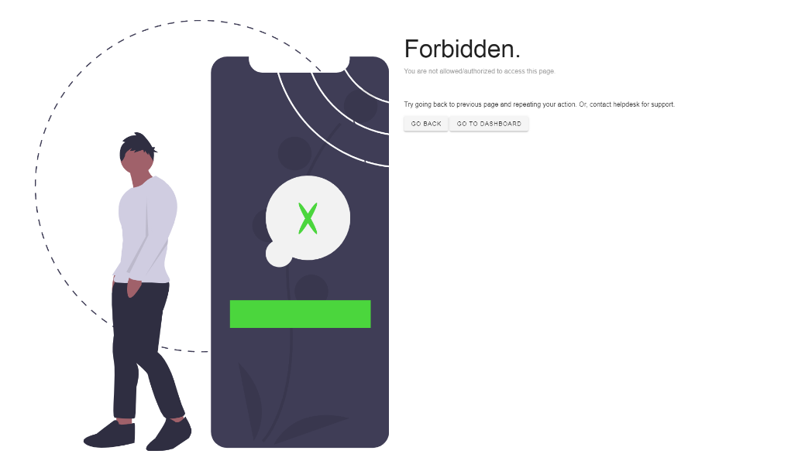

Figure 93 403 Forbidden Page

#### 404 Not Found

The server cannot find the requested resource. This means that the URL or endpoint is valid but the resource itself does not exist. The user will be redirected to the error page like the image shown below:



Figure 94 404 Not Found Page

#### 422 Unprocessable Entity

The request was well-formed but was unable to be followed due to semantic errors.

#### 500 Internal Server Error

This means that the server has encountered a situation that it does not know how to handle. Furthermore, this indicates a problem with the server, not the actual availability of the content. The user will be redirected to the error page like the image shown below:

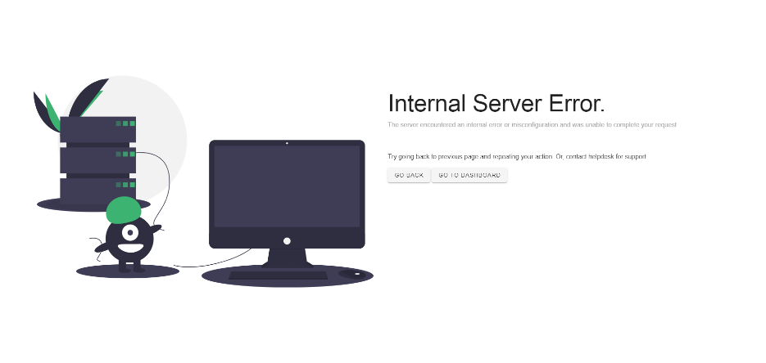

Figure 95 500 Internal Server Error Page

#### 503 Service Unavailable

This means that the server is currently not ready to handle the request. This is a common occurrence when the server is down for maintenance or is overloaded. The user will be redirected to the error page like the image shown below:

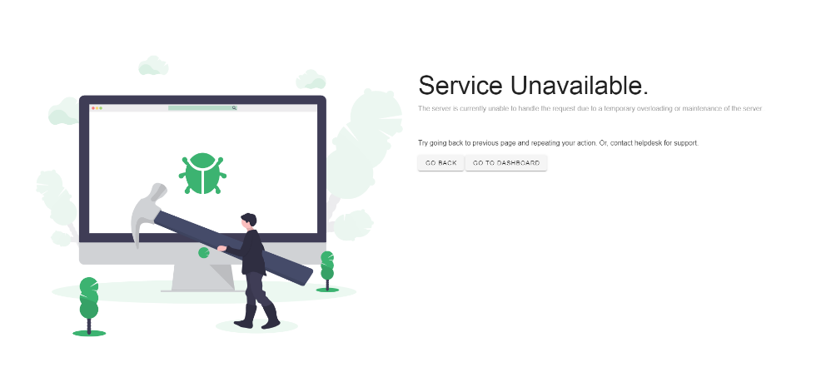

Figure 96 503 Service Unavailable